Diagnostic Dilemma: Large Primary Ovarian Leiomyoma Imitating Fibroma in a Postmenopausal Patient: Case Report
¹Dr Ruchi Sinha, ^{2*}Dr Preetika Sinha,³Dr Tarun Kumar, ³Dr Avinash Singh, ²Dr Shankhanila Mazumdar
¹Professor, Department of Pathology & Laboratory Medicine, College of All India Institute of Medical Sciences, Patna
²Senior Resident, Department of Pathology & Laboratory Medicine, College of All India Institute of Medical Sciences, Patna
³Associate Professor, Department of Pathology & Laboratory Medicine, College of All India Institute of Medical Sciences, Patna

Abstract
Primary ovarian leiomyoma is extremely uncommon, with a low incidence rate of 0.5-1% of benign ovarian tumors. Due to its rarity, it poses a diagnostic dilemma and needs to be differentiated from other spindle cell neoplasms of the ovary. We report a case of a large symptomatic primary ovarian leiomyoma in a postmenopausal woman, which was misdiagnosed as fibroma of the ovary both clinically and radiologically. Microscopy revealed a spindle cell tumor arranged in short intersecting fascicles, which were positive for SMA and h-caldesmon on immunohistochemistry. is a useful adjunct for definitive diagnosis and confirming smooth muscle origin. While malignant solid ovarian tumors are much more common, the consideration of ovarian leiomyoma as a differential diagnosis of solid ovarian tumors is essential, as the treatment modality is surgical resection. Diagnosing ovarian leiomyoma before and during surgery is challenging. It is advisable to perform both histopathological examination and immunohistochemical analysis.

Keywords: Ovarin leiomyoma, postmenopausal, primary, immunohistochemistry.
Submitted: June 04, 2026 Accepted: July 06, 2026 Published: August 18 , 2026
Corresponding author: Dr Preetika Sinha,
Email: dr.preetika.sinha@gmail.com
Senior Resident, Department of Pathology & Laboratory Medicine, College of All India Institute of Medical Sciences, Patna

Introduction
Leiomyomas are benign tumors of smooth muscle origin. While predominantly occurring in the uterus, they can also be found in extra-uterine locations [1]. Ovarian leiomyomas, although the most common mesenchymal tumors of the ovary, are rare benign tumors that make up only 0.5% to 1% of cases [2]. Other uncommon sites include the broad ligament, vulva, ovarian ligament, urethra, and urinary bladder [3]. According to published reports, ovarian leiomyoma usually occurs unilaterally, is small, and often presents with non-specific symptoms in premenopausal women [4, 5]. They must be distinguished from thecomas and fibromas [4, 5]. Postmenopausal ovarian leiomyomas account for only one-sixth of these cases [6].
To date, fewer than 100 cases of ovarian leiomyoma have been reported. In this study, we describe a case of primary ovarian leiomyoma in a 45-year-old postmenopausal woman, initially misdiagnosed as an ovarian fibroma based on clinical and radiological assessments.

Case Report
A 45-year-old postmenopausal woman presented with complaints of abdominal pain for the last 5 years. The abdominal pain was insidious in onset, of moderate to severe intensity, and radiated to the back. The patient had undergone a vaginal hysterectomy 20 years ago for uterine fibroids. On per vagina examination, a firm to hard, mobile, irregular abdomino-pelvic mass measuring 14 to 18 weeks in size was palpable. There was also the presence of a primary cystocele. The patient's other physical examinations and per abdomen examination were unremarkable.

Her laboratory investigations, including complete blood count and serum levels of CEA, CA-125, and CA 19.9, were within the normal range. Transvaginal pelvic sonography revealed a well-demarcated, solid, homogeneous, hypoechoic mass measuring 8.9 cm by 8.1 cm in the right adnexa, suggesting the possibility of an ovarian fibroma.

The patient underwent exploratory laparotomy. Following the midline longitudinal infraumbilical incision, the abdomen was opened in layers, 20 ml of ascitic fluid was aspirated and sent for cytology. Intra-operatively, a solid, firm mass was identified along the right ovary, favoring a fibroma. There was no adhesion or infiltration into the adjacent structures. The left ovary appeared normal. Bilateral fallopian tubes showed hydrosalpinx. Right salpingectomy along with left salpingo-oophorectomy were performed. The right ovarian mass was excised separately. Postoperatively, vital signs remained stable. The patient voided normally following catheter removal.

The excised specimens, including the right ovarian mass, right salpingectomy, and left salpingo-oophorectomy, were sent for histopathology. Gross examination revealed that the right ovarian mass was well-encapsulated, solid, and grey-white with a bosselated exterior measuring 9.5 cm x 8 cm x 7.5 cm (Figure 1A). The cut surface displayed heterogeneous grey-white areas with a whorled pattern, focal myxoid regions, and foci of subcapsular hemorrhage (Figure 1B). Grossly, no necrosis or calcification was noted. The left ovary appeared grossly unremarkable. Both fallopian tubes were dilated.

Microscopically, the right ovarian mass showed a well-circumscribed, unencapsulated tumor arranged in short fascicles and a whorled pattern within a variably collagenized stroma. The tumor cells exhibited bland, uniform spindle nuclei, inconspicuous nucleoli, and varying amounts of eosinophilic cytoplasm (Figure 2A-B). There was no nuclear atypia, increased mitosis, or necrosis, ruling out the possibility of a malignant neoplasm. No sex cord-stromal component was identified. Some areas showed myxoid degeneration. The tumor was seen compressing the adjacent normal ovarian parenchyma, including the corpus albicans and corpus luteum.

Immunohistochemistry revealed diffuse strong positivity for smooth muscle actin and h-caldesmon in the tumor cells, confirming the diagnosis of ovarian leiomyoma. (Figure 3A-B). The tumor was immunonegative for calretinin and inhibin, ruling out ovarian fibroma and other sex cord-stromal tumors. The proliferation index (Ki-67) was 2-3% (Figure 4A-C).

The post-surgical period was uneventful. By postoperative day 3, the wound was clean with a healthy stitch line, no induration or discharge. The patient was discharged on a high-protein diet, activity restriction, and oral cefuroxime (500 mg BD, 4 days), with symptom resolution at the next two OPD follow-ups.

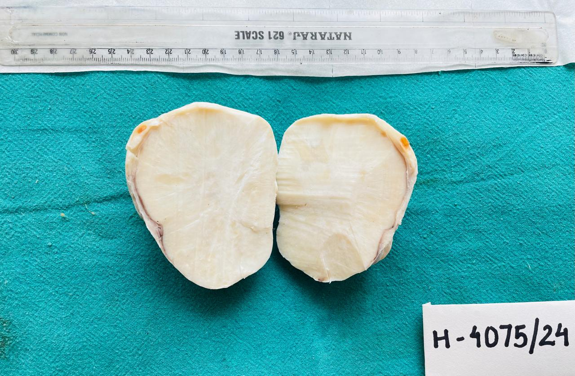
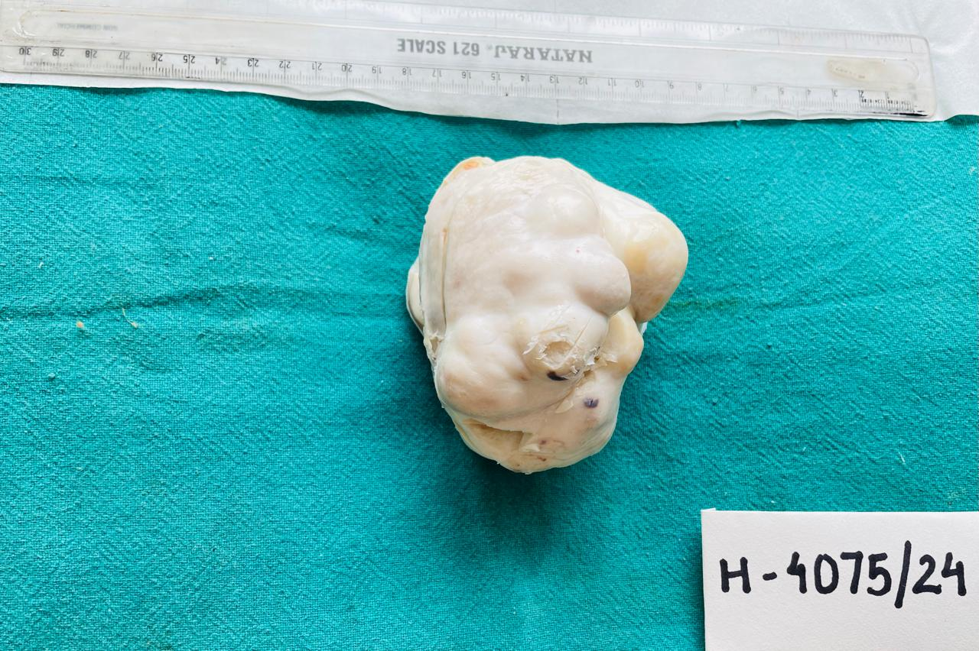
B
A
Figure 1: Specimen of right ovarian mass: A well-circumscribed solid mass with white glistening, bosselated external surface. (A) White to yellow cut surface with focally whorled pattern. (B)
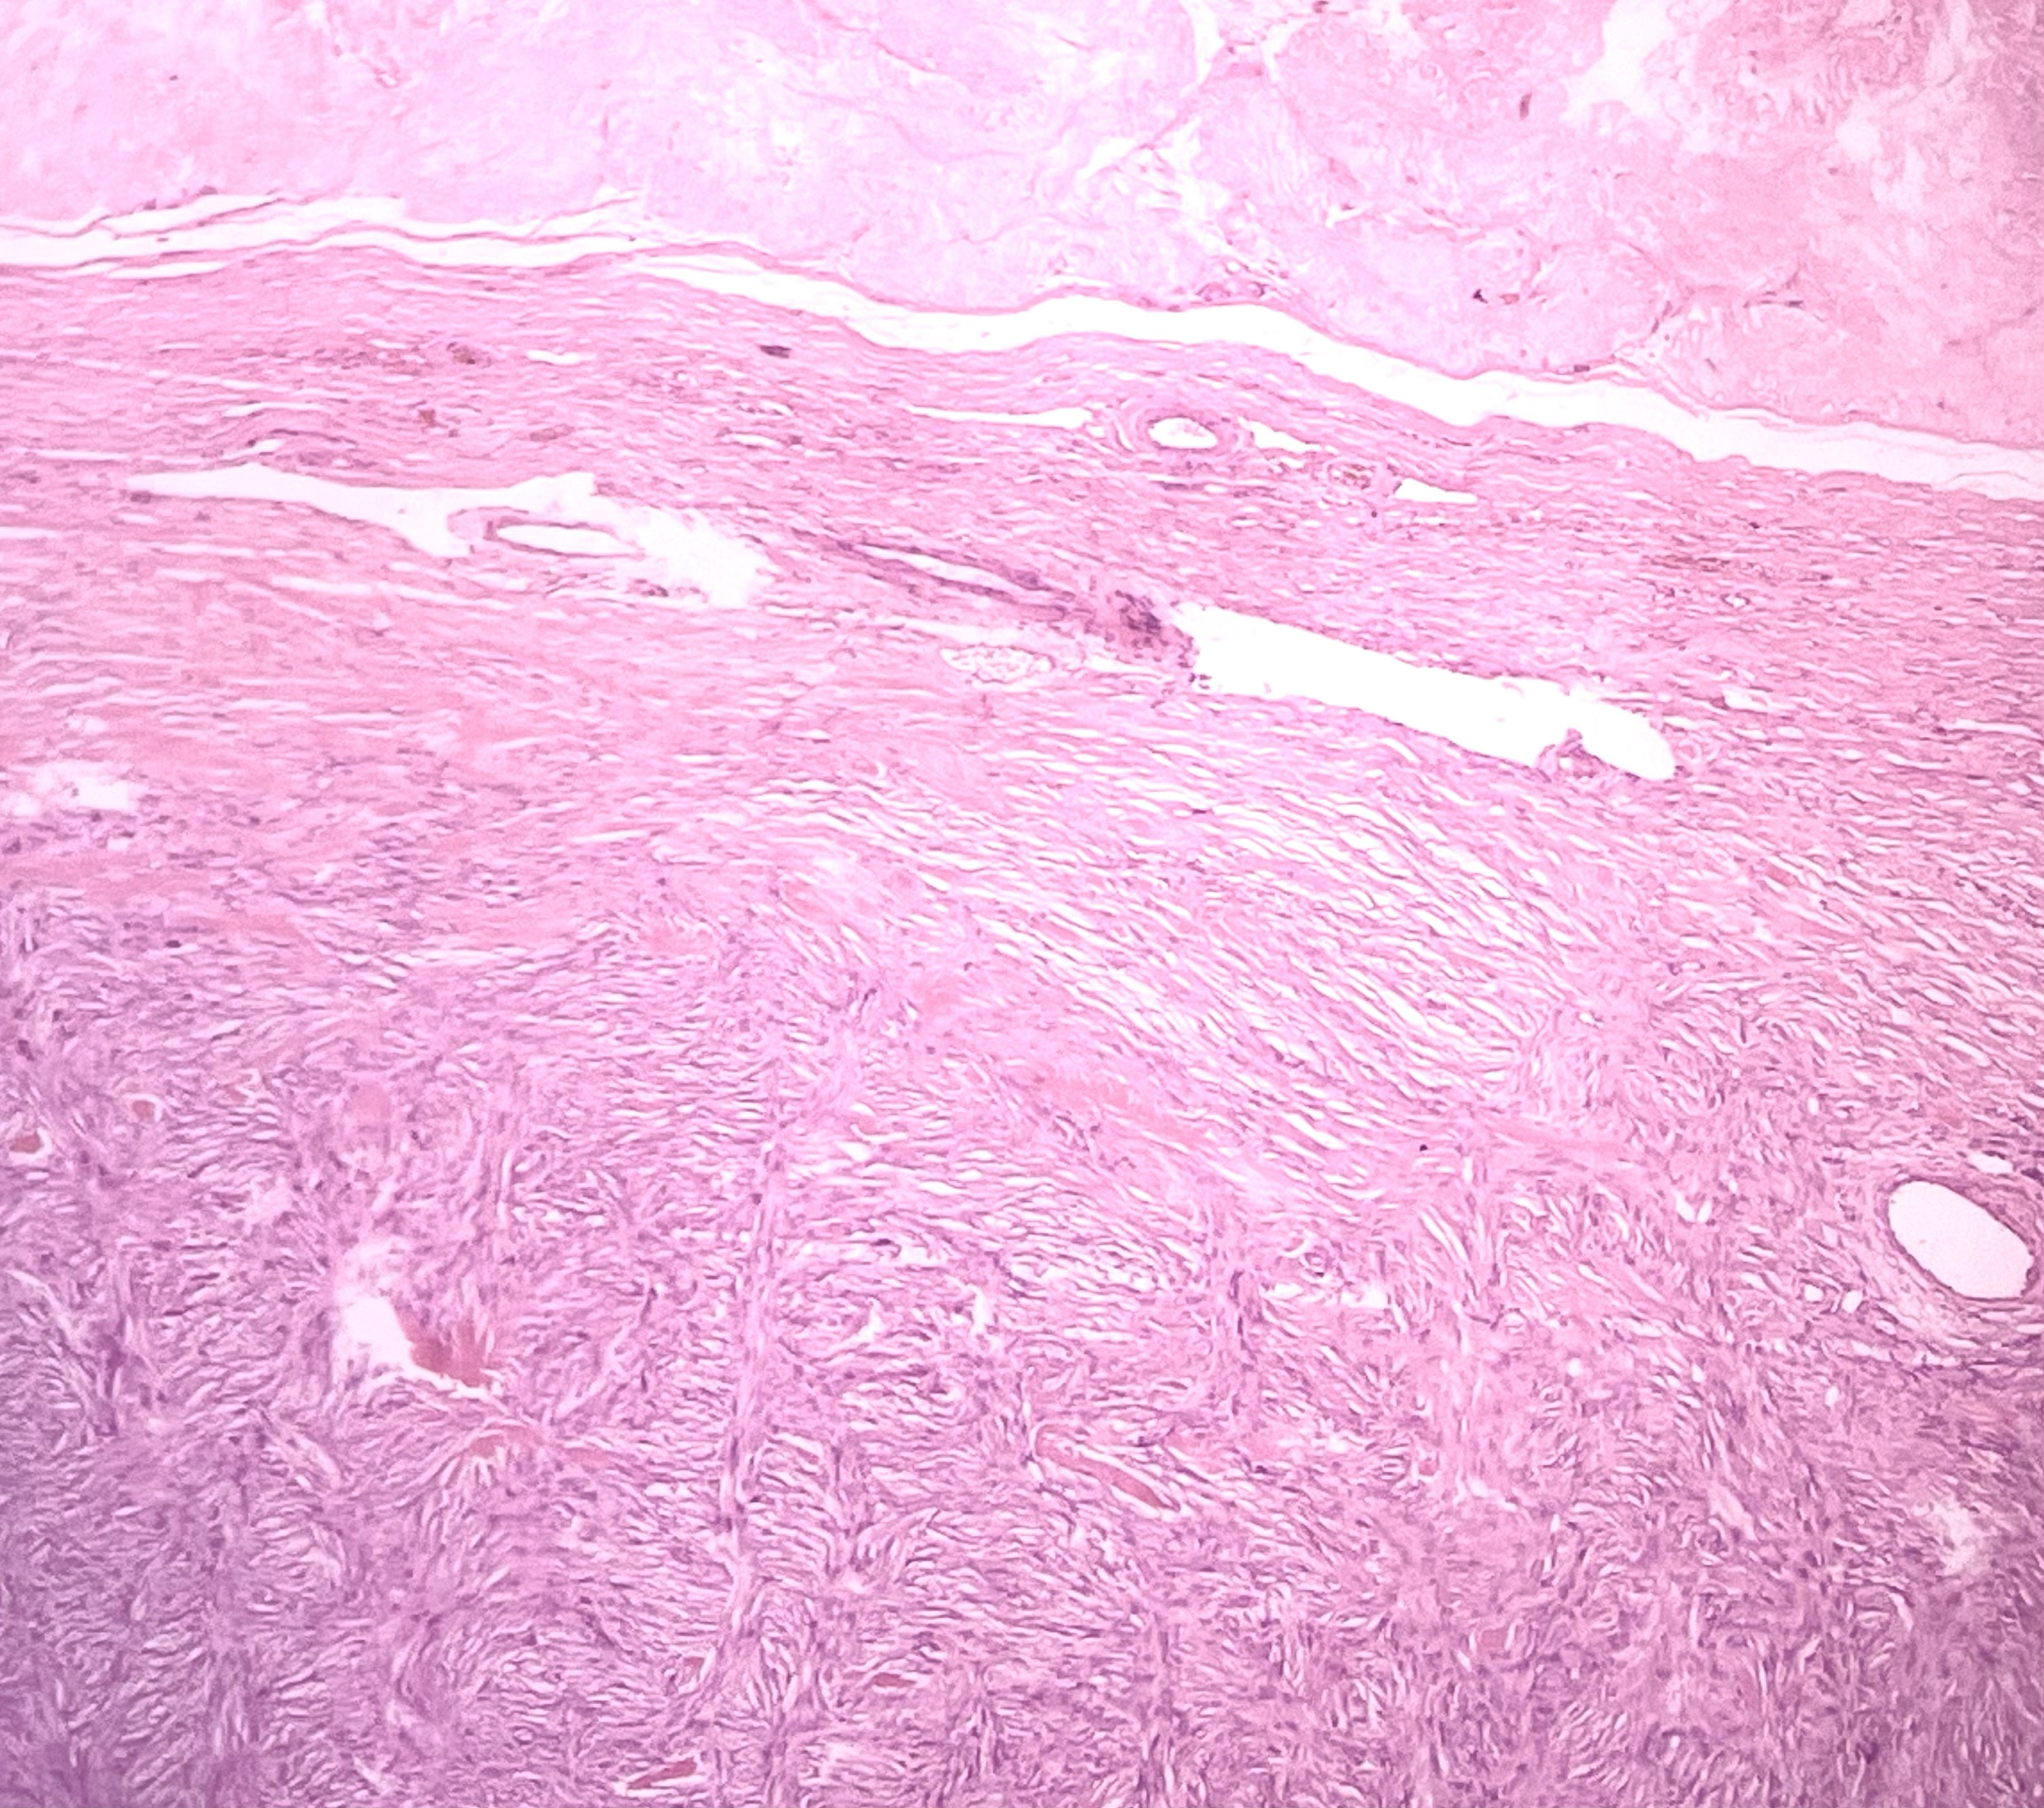
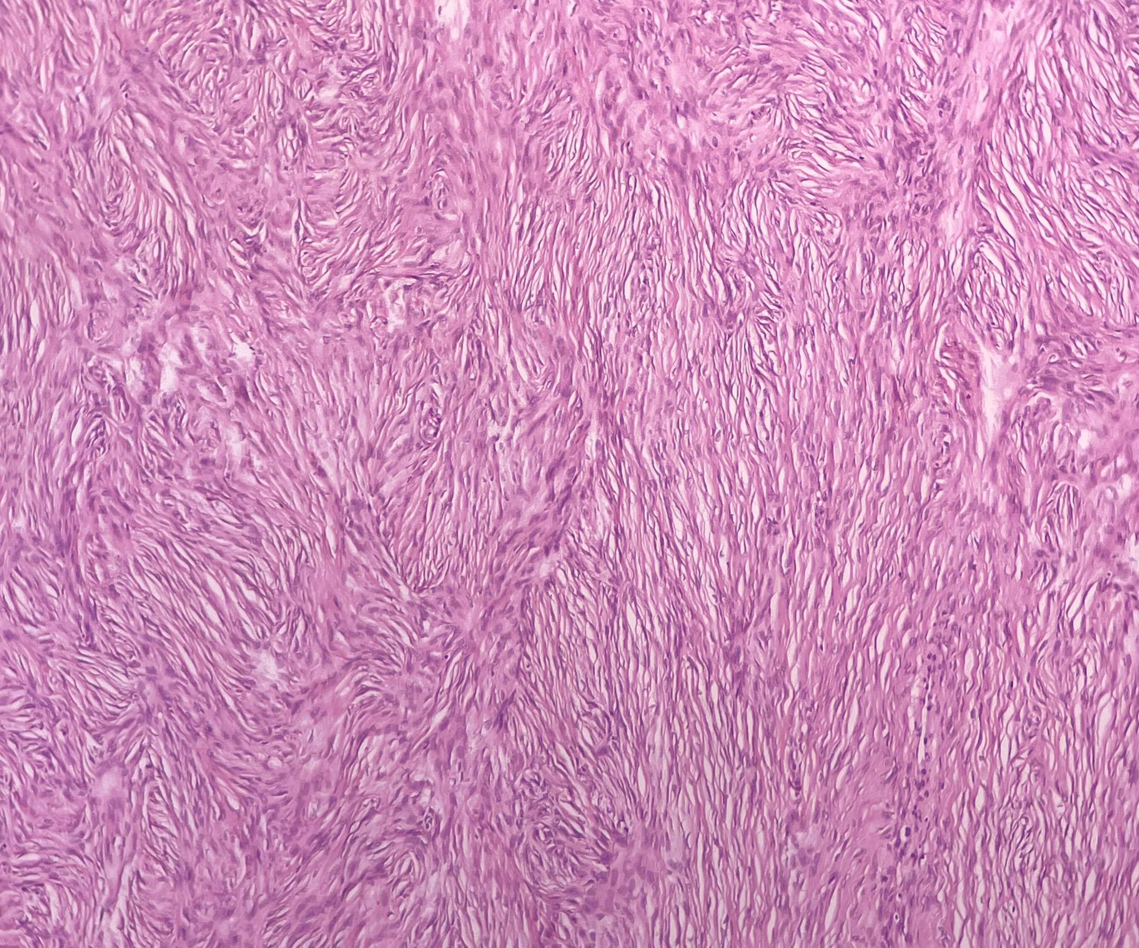
A
B
Figure 2 : (A) Tumor composed of fascicular and storiform arrangement and peripherally surrounded by compressed ovarian stroma (corpus luteum) (H&E x 100). (B) Area showing prominent storiform pattern (H&E x 100)
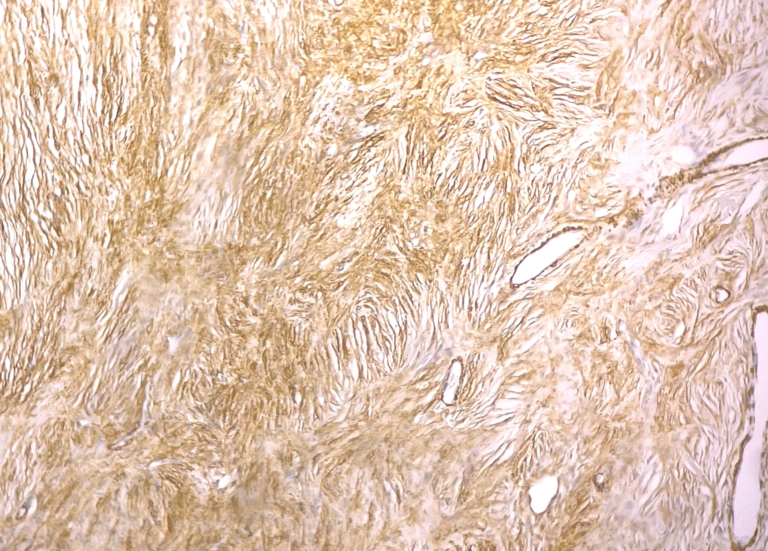
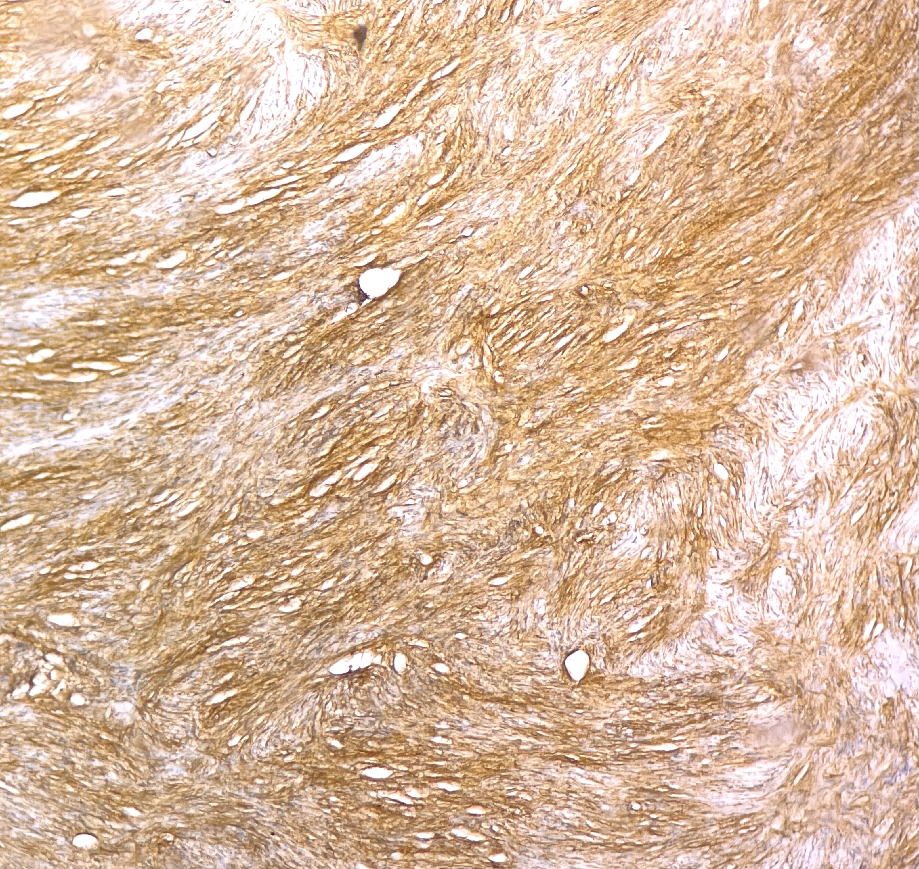
A
B
Figure 3: Tumor cells exhibited diffuse strong immunoreactivity for alpha smooth muscle actin (A) and h-caldesmon (B) (H&E x 100)
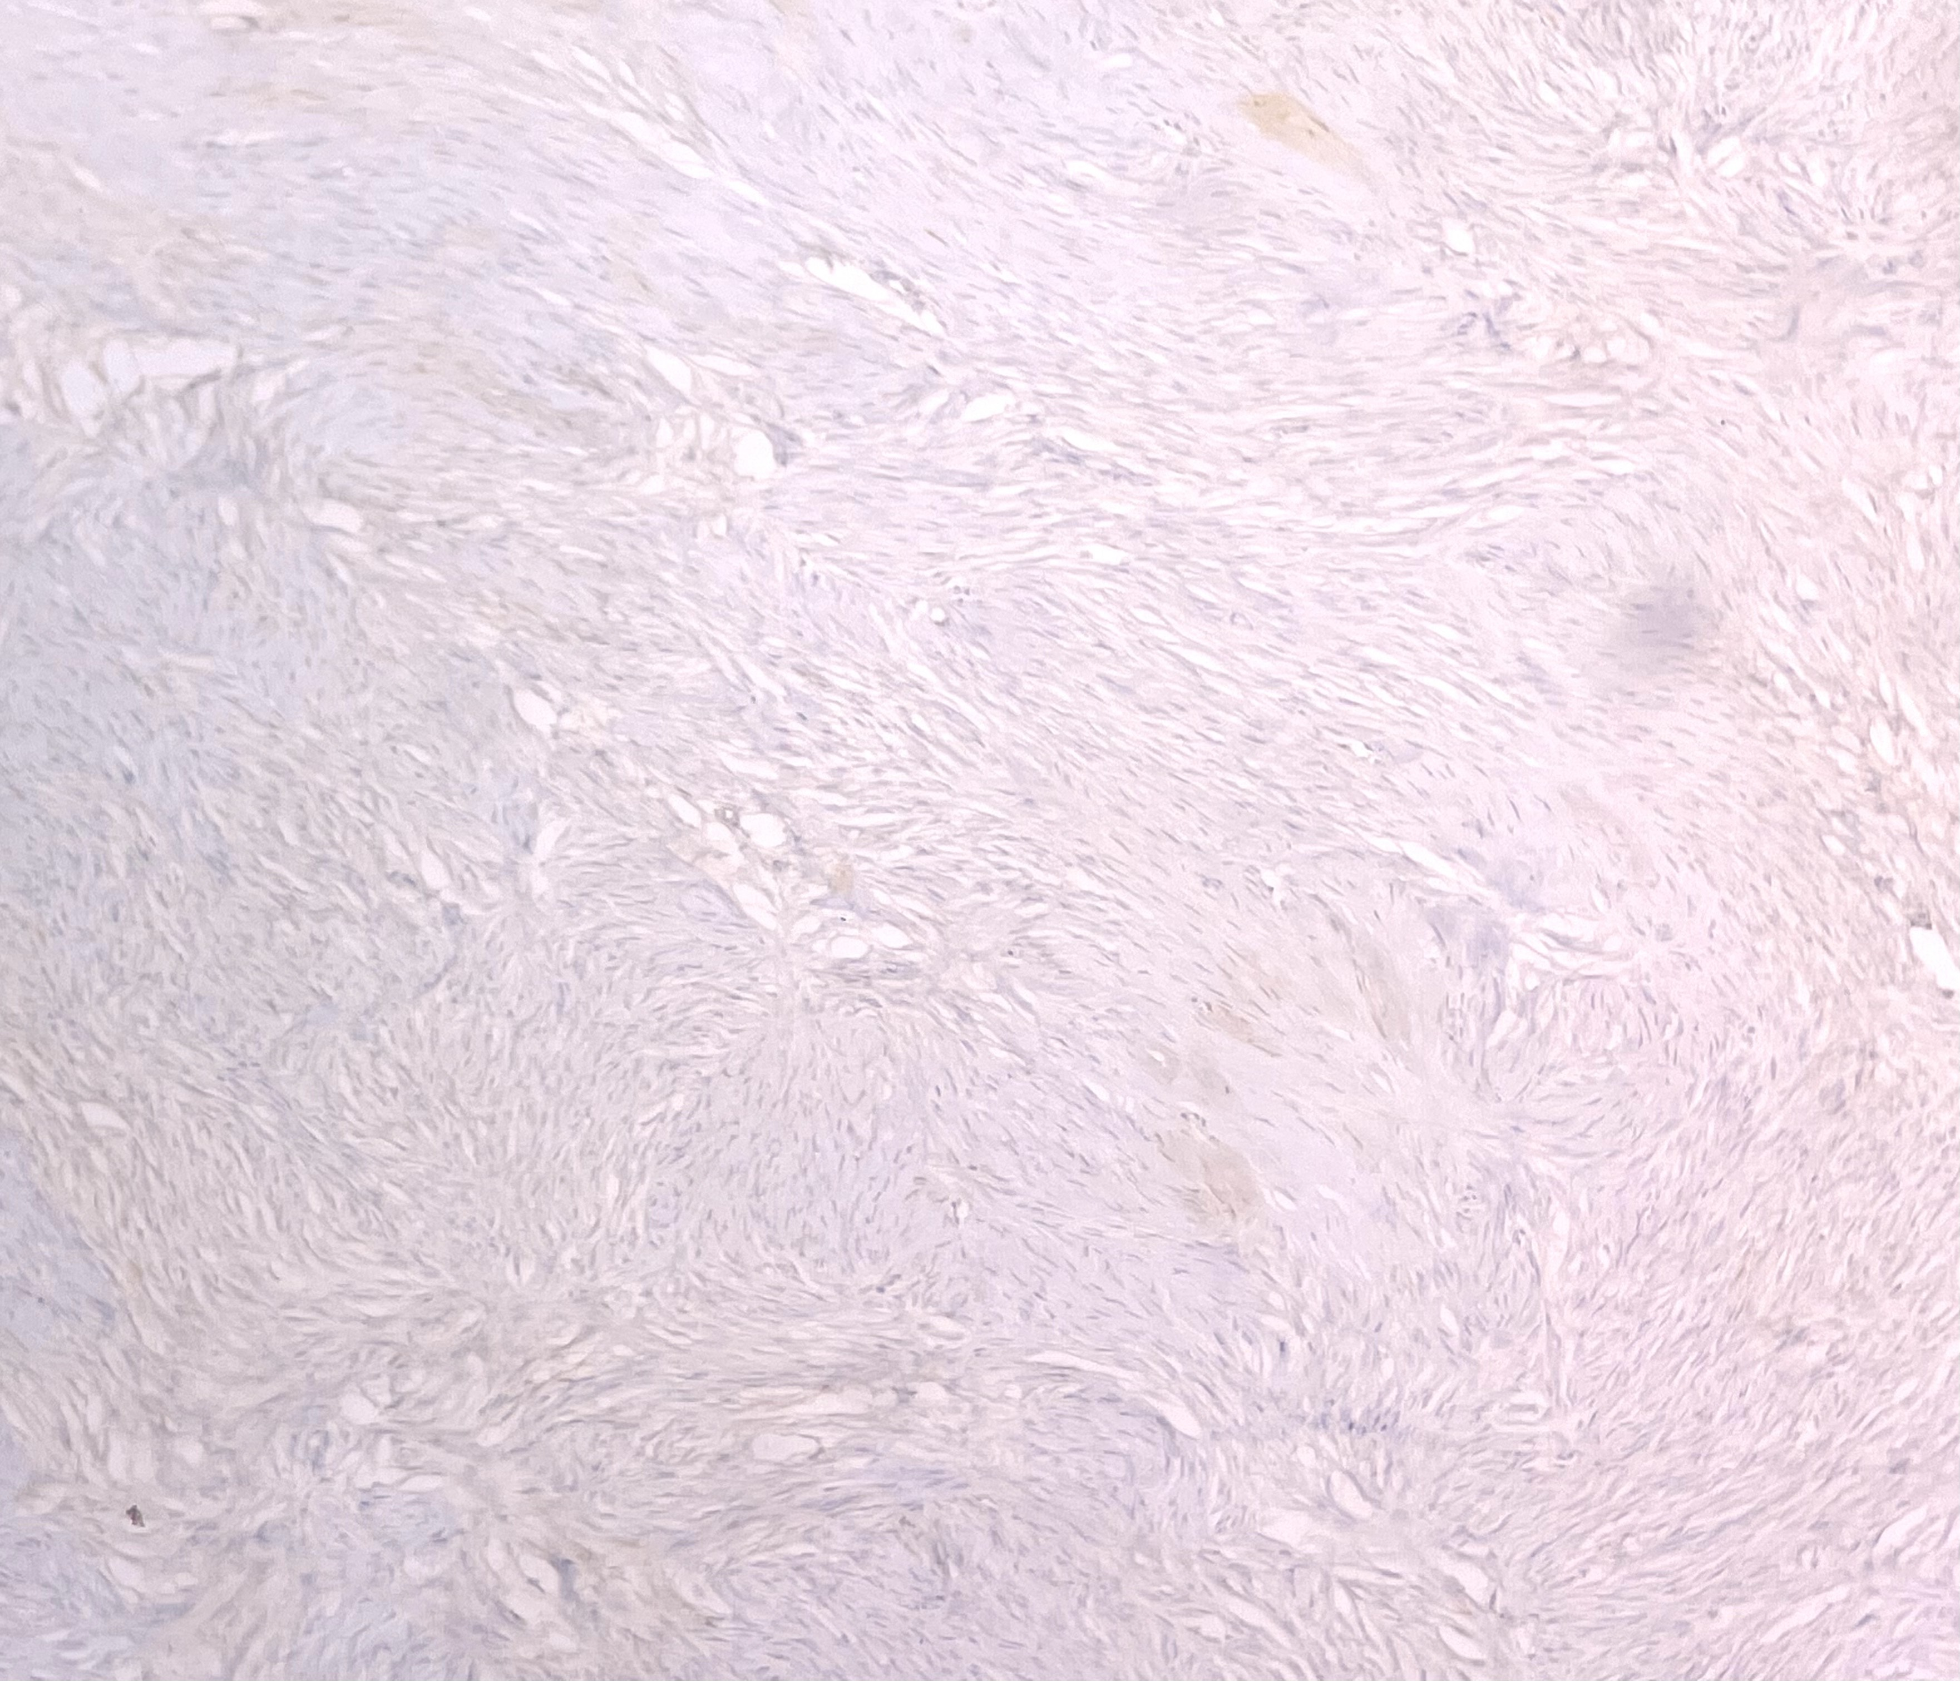
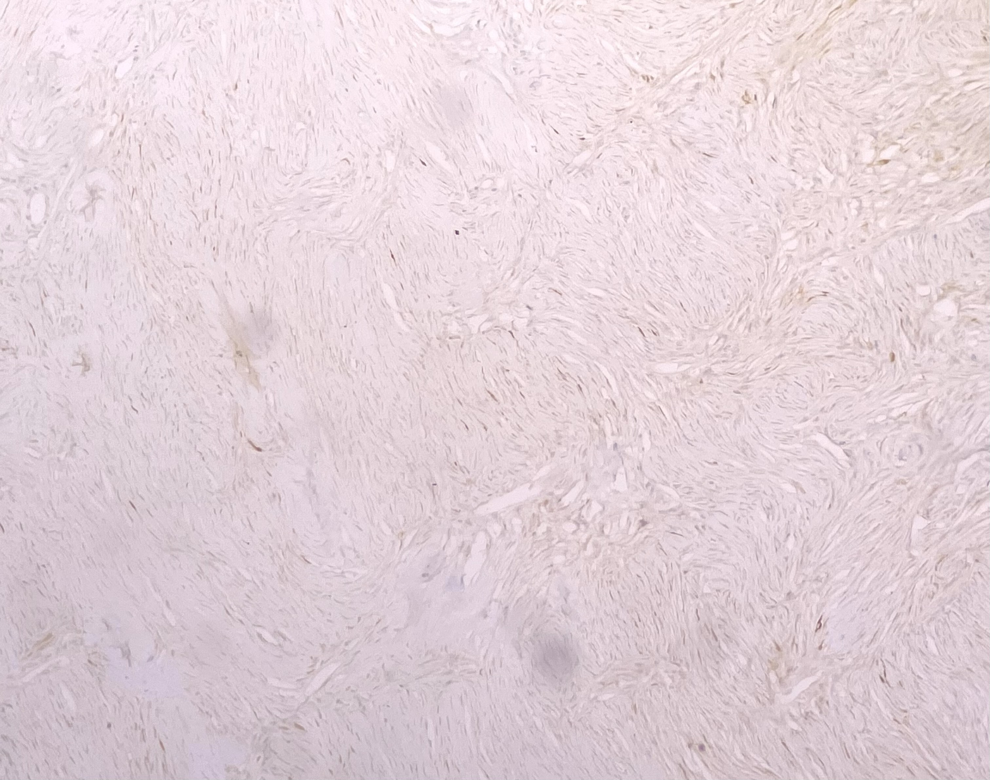
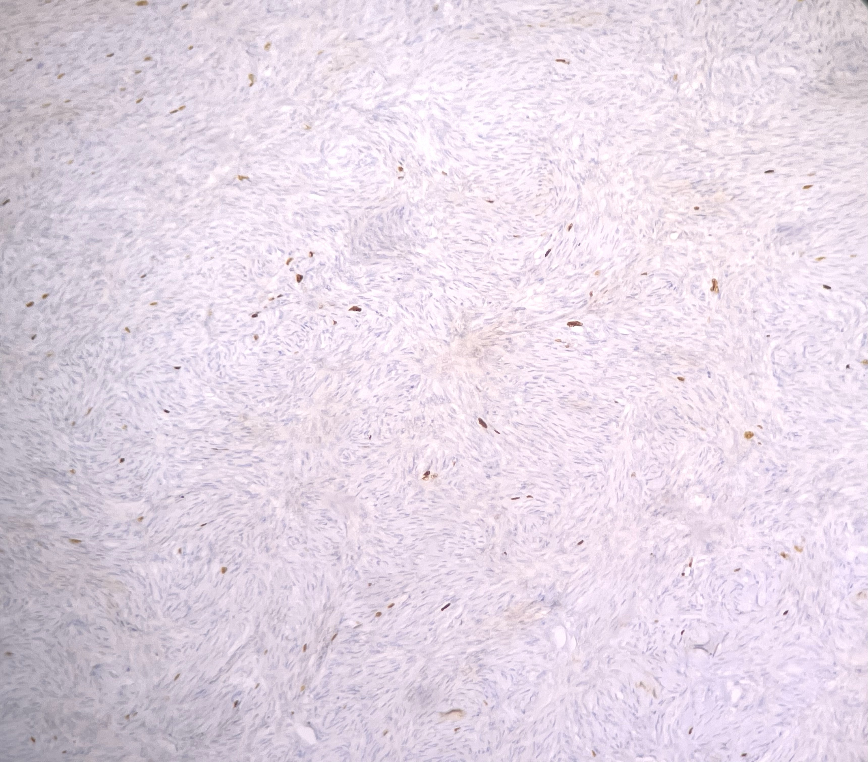
A
B
C
Figure 4: Tumor exhibited negative immunostaining with Inhibin (A) and Calretinin (B). Proliferative index (Ki-67) is 2-3% (C) (H&E x 100)

Discussion
Ovarian leiomyomas, while being the most common mesenchymal tumors of the ovary, are extremely rare benign tumors of the ovary, accounting for 0.5% - 1% of cases [2]. The first ever mention of primary leiomyoma of the ovary was in 1862 by Fallahzadeh et al [17]. Most of these patients remain asymptomatic because of the small size (less than 3 cm) and are often found incidentally during routine pelvic exams, imaging studies, or surgeries [4,5]. Larger or giant ovarian leiomyomas tend to cause symptoms, with patients usually presenting with abdominal pain, ascites, hydronephrosis, elevated serum CA-125 levels, hydrothorax, or even polymyositis [6,9].
This is in concordance with our case, which was a 10 cm mass and a patient with a history of chronic, progressive abdominal pain. While most reports describe unilateral leiomyomas, there have been cases of bilateral ovarian leiomyomas, particularly in young and pediatric patients [5]. These tumors mainly occur in premenopausal women, with only 16% of cases found in postmenopausal women [6]. A review of the published literature reveals fewer than 100 reported cases of primary ovarian leiomyoma [6]. In some instances, ovarian leiomyoma has been associated with Meigs Syndrome [3]. In our case, the serum levels of CEA, CA-125, and CA 19-9 were within the normal range. Occasionally, these tumors can twist around their pedicle, causing hemorrhage and necrosis. While most are mobile, some may adhere to the omentum, intestine, or uterus [2]. Like uterine leiomyomas, ovarian leiomyomas can also undergo secondary changes [2].
78% of ovarian leiomyomas are found alongside uterine leiomyomas, suggesting shared hormonal influence [10, 11]. Some authors believe that the synchronous presence can result from a secondary process, where a pedunculated subserosal leiomyoma loses its uterine attachment and attaches to the ovary [6, 11]. Estrogen and developmental anomalies of the ovary are also suggested to play a role in the development of ovarian leiomyomas [12].
Pinpointing an exact theory for the origin of primary ovarian leiomyoma is challenging. However, it is hypothesized that they may develop from the ovarian ligament, smooth muscle cells, multipotential cells in the ovarian stroma, ovarian hilar blood vessels, cortical smooth muscle metaplasia, smooth muscle metaplasia of endometrial stroma, undifferentiated germ cells, or smooth muscle within mature cystic teratomas or mucinous cystic tumors[13,14]. In our case, although the patient underwent surgical menopause 20 years ago for a uterine leiomyoma, the presence of normal ovarian tissue around the lesion supports the diagnosis of primary ovarian leiomyoma, likely originating from smooth muscle cells, possibly from the vascular wall or ovarian stroma.
Identifying and characterizing an intrapelvic, solid, isoechoic mass as an ovarian leiomyoma using ultrasonography can be very challenging. Such masses are often mistaken for ovarian fibroma or thecoma. MRI is a valuable complementary tool that can aid diagnosis by showing low-intensity signals on T1- and T2-weighted images, characteristic of leiomyoma [15]. In our case, the patient did not undergo any additional imaging beyond ultrasonography, which led to a diagnostic pitfall [16].

Microscopically, it is essential to distinguish Leiomyoma from Ovarian Fibroma, the latter having a more storiform pattern & spindle cells with pointed nuclei. On the contrary, leiomyoma is characterized by intersecting fascicles of spindle cells with blunt-ended nuclei and moderate to abundant eosinophilic cytoplasm. [18] Immunohistochemistry aids in confirming the smooth muscle origin and rules out fibroma and thecoma. The strong diffuse positivity for SMA and h-caldesmon suggests leiomyoma. They do not stain with calretinin and inhibin, unlike fibroma and thecoma. [1] Differentiating leiomyoma from leiomyosarcoma is essential and involves thorough examination of multiple fields for tumor necrosis, significant cytological atypia, and comparison of proliferative index with standard thresholds.[5]

Conclusion
A leiomyoma is a benign tumor of mesenchymal origin, typically occurring in the uterus and rarely in the ovary. Although malignant solid ovarian tumors are more common, it's important to consider ovarian leiomyoma as a differential diagnosis because the treatment usually involves surgical removal. Diagnosing ovarian leiomyoma before or during surgery can be difficult. To definitively identify a primary ovarian spindle cell tumor, it is recommended to conduct both histopathological and immunohistochemical analyses.

Financial support and sponsorship
Nil

Conflicts of interest
There are no conflicts of interest.

Takeaway lessons
Primary ovarian leiomyoma is exceedingly rare, but should always be kept on the differential for a solid ovarian mass, since it is clinically and radiologically indistinguishable from fibroma or thecoma. Intraoperative and gross impression alone is unreliable. Histomorphology can overlap significantly with fibroma, so IHC is essential for definitive diagnosis. Since ovarian leiomyoma is often associated with uterine leiomyomas, a history of uterine fibroids in a patient should raise suspicion. Malignant potential must always be excluded by systematically assessing for nuclear atypia, mitotic activity, necrosis, and proliferative index.

Acknowledgement
The authors thank the Departments of Pathology & Laboratory Medicine and Obstetrics & Gynaecology, AIIMS Patna, for their support in the clinical management, histopathological processing, and immunohistochemical analysis of this case. We also acknowledge the patient for her cooperation with this case.

Abbreviations
CEA – Carcinoembryonic Antigen
CA-125 – Cancer Antigen 125
CA 19-9 – Cancer Antigen 19-9
SMA – Smooth Muscle Actin
H&E – Hematoxylin and Eosin (stain)
IHC (implied, "immunohistochemistry") – Immunohistochemistry
Ki-67 – proliferation/proliferative index marker
MRI – Magnetic Resonance Imaging
T1/T2 – T1-weighted / T2-weighted (MRI sequences)
WHO – World Health Organization

Data availability
Data is available upon request

Author Contributions Statement
Dr Ruchi Sinha - Supervision, Validation, Writing – Review & Editing
Dr Preetika Sinha - Conceptualization, Investigation, Writing – Original Draft
Dr Tarun Kumar - Formal Analysis, Writing – Review
Dr Avinash Singh - Data Curation, Writing – Review
Dr Shankhanila Mazumdar – Resources, Visualization

References
- Moch H, editor. Female genital tumours: WHO classification of tumours. 5th ed. Vol. 4. Lyon (FR): International Agency for Research on Cancer; 2020.
- Agarwal R, Kumar M, Agarwal L, Agarwal KK. A huge primary ovarian leiomyoma with degenerative changes: An unusual presentation. J Clin Diagn Res. 2013;7:1152-4. https://doi.org/10.7860/JCDR/2013/5313.3060
- Kurai M, Shiozawa T, Noguchi H, Konishi I. Leiomyoma of the ovary presenting with Meigs' syndrome. J Obstet Gynaecol Res. 2005;31:257-62. https://doi.org/10.1111/j.1447-0756.2005.00285.x
- Blue NR, Felix JC, Jaque J. Primary ovarian leiomyoma in a premenarchal adolescent: First reported case. J Pediatr Adolesc Gynecol. 2014;27:87-8. https://doi.org/10.1016/j.jpag.2013.07.011
- Taskin MI, Ozturk E, Yildirim F, Ozdemir N, Inceboz U. Primary ovarian leiomyoma: A case report. Int J Surg Case Rep. 2014;5:665-8. https://doi.org/10.1016/j.ijscr.2014.07.020
- Meel M, Hemrajani D, Kumar M, Agnani B. Symptomatic primary ovarian leiomyoma in a postmenopausal woman: A rare entity. J Midlife Health. 2020;11:175-7 https://doi.org/10.4103/jmh.JMH_105_19
- Rajesh S, Adam M. Benign metastasizing leiomyoma: "A sheep in wolf's clothing." Community Oncol. 2013;10:122-5 https://doi.org/10.12788/j.cmonc.0006
- Lerwill MF, Sung R, Oliva E, Prat J, Young RH. Smooth muscle tumors of the ovary: a clinicopathologic study of 54 cases emphasizing prognostic criteria, histologic variants, and differential diagnosis. Am J Surg Pathol. 2004 Nov;28(11):1436-51. doi:10.1097/01.pas.0000141393.99300.d0. PMID: 15489647.
- https://doi.org/10.1097/01.pas.0000141393.99300.d0
- Erdemoglu E, Kamaci M, Bayram I, Güler A, Güler Sahin H. Primary giant leiomyoma of the ovary--case report. Eur J Gynaecol Oncol. 2006;27(6):634-5. PMID: 17290603.
- 10 Pandit MJ, Watson NR, Mackenzie IZ. Leiomyoma of the ovary. J Obstet Gynaecol. 1997;17:503-4
https://doi.org/10.1080/01443619750112664
- 11 Lim SC, Jeon HJ. Bilateral primary ovarian leiomyoma in a young woman: Case report and literature review. Gynecol Oncol. 2004;95:733-5 https://doi.org/10.1016/j.ygyno.2004.07.048
- 12 Bharti S, Khera S, Sharma C, Balakrishnan A. Unilateral primary ovarian leiomyoma masqueraded as ovarian fibroma: A histopathological diagnosis. Journal of Family Medicine and Primary Care 10(9):3494-3497, September 2021. https://doi.org/10.4103/jfmpc.jfmpc_2546_20
- 13 Patne SC, Kumar M, Raghuvanshi S, Agarwal NR. Unilateral primary ovarian leiomyoma with degeneration masquerading as ovarian malignancy. World J Surg Res. 2013;2:50-3
- 14 Kataria SP, Chawla N, Singh G, Kum S. Ovarian leiomyoma associated with serous cystadenoma - A case report of an uncommon entity. Global J Pathol Microbiol. 2014;14:38-42
- 15 Yasushi K., Noriyuki T., Masako S., Kaei N., Isao M. Magnetic resonance imaging findings in leiomyoma of the ovary: a case report. Arch Gynecol Obstet. 2005;273:298-300. https://doi.org/10.1007/s00404-005-0085-z
- 16 Tomas D., Lenicek T., Tuckar N., Puljiz Z., Ledinsky M., Kruslin B. Primary ovarian leiomyoma associated with endometriotic cyst presenting with symptoms of acute appendicitis: a case report. Diagn Pathol. 2009;4:25
https://doi.org/10.1186/1746-1596-4-25
- 17 Fallahzadeh H, Dockerty MB, Lee RA. Leiomyoma of the ovary: Report of five cases and review of the literature. Am J Obstet Gynecol 1972;113:394‐8. https://doi.org/10.1016/0002-9378(72)90691-6
- 18 Gunasekaran I, Phansalkar M, Palo LB, Varghese RG. Ovarian Leiomyoma Along with Uterine Leiomyomata: A Common Tumour at an Uncommon Site. J Clin Diagn Res. 2015 Nov;9(11)
https://doi.org/10.7860/JCDR/2015/13378.6703

PUBLISHER DETAILS


